The Staff Galloper
‘Incorporating the Shamrock’
The Newsletter of the North Irish Horse Regimental Association
And North Irish Horse Benevolent Trust
May 2022

THE HITLER LINE 2022 SPECIAL

Yes! At last, we can confirm the Hitler Line celebration will be taking place’
in Carrickfergus on, Saturday 21st May 2022
Apologies for the late transmission of this newsletter

The North Irish Horse
Hitler Line Parade 78th Anniversary Celebration.

The year 2022 marks the 78th Anniversary of the breaching of the Adolf Hitler Line on 23 May 1944. To celebrate this unique occasion the Guidon of the Scottish and North Irish Yeomanry (SNIY) is to be paraded in Carrickfergus. This will be the second time that the SNIY Guidon has been paraded in
Carrickfergus since it was presented to the Regiment in September 2018. The guards for the Guidon will be formed by B (NIH) Sqn SNIY, 40 (NIH) Sig Sqn 32 Sig Regt and a composite guard formed by members of our sister squadrons from the SNIY. Members of the North Irish Horse Regimental Association (NIHRA) together with the cadets of the Dunmore (cadet) detachment of the Royal Dragoon Guards (RDG), and the cadets of the Laurelhill Community College, Combined Cadet Force (CCF) SNIY are to be invited to join the parade. The Regimental Band of the Royal Irish Regiment (RIR) will be on parade augmented by the Pipes and Drums of the SNIY.

The parade is to take place in Carrickfergus castle Car Park. An outline programme of events is as follows.

10.15 am. Guests and members of the NIHRA to be seated.
10.30 am. The marching troops will march on to the parade.
10.35 am. HMLL, the Mayoral party, and VIPs arrive.
10.40 am. The Act of Remembrance and wreath laying ceremony.
11.00 am. Inspection of the parade by HMLL.
11.15 am. The presentation of the Maple Leaf
12.15 pm. The Commemoration Service. Immediately after the presentations the parade will march to Saint Nicholas Church. The congregation are asked to be seated by 12.05 pm.
01.00 pm. At the conclusion of the Commemoration Service the parade will return to the Townhall.
01.00 pm. The reception.

The reception. Admission to the reception is free. Admission for all non-uniformed NIHRA members and guests’ will be by ticket. NIHRA members wishing to attend the reception should apply for tickets by completing Appendix “A”. The completed appendix to be returned, at the latest, by Saturday 14th May 2022 to: Secretary NIHRA, the address is shown on Appendix “A”
(Continued…………….

………………The Reception continued}

As accommodation is only available for 300 persons, tickets will be issued on the principle of first come first served.

As the reception is “free, gratis and for nothing” provision will be made for those attending the reception to make donations to the NIH Benevolent Trust.

Car Parking: Car parking will be at a premium and will be available in the Joymount and Main Street (Cenotaph) car park. Tickets will be issued on application see Appendix “A”

Programme of events; A detailed programme of events will be distributed on arrival at the parade. There may be changes to some of the intermediate times
An Invitation to an Open House Bonanza
Major Derek Irvine and all the members of 40 (NIH) Signal Squadron cordially invite you to their “Open House Bonanza” to celebrate the battle for the Hitler Line’s 78th Anniversary. The event is scheduled for:
Saturday 21st May 2022 and is to be held in Clonaver Park ARC
The doors will swing open to the sound of live music at 1430 hours, and you will be entertained by a Disco, a lady vocalist and karaoke, at 1830 hours You will be invited to feast from either; chicken curry or beef stroganoff and a choice of puddings. (Special dietary requirements will be catered for, but they should be notified in advance). Entry to this event is Free and for Nothing.
See Appendix “B” for the return and more information. For further information contact SSgt Kelly Reid

It Gets Even Better

I have been advised that the former members of B Sqn NIH, and the members of the former 69 (NIH) Sig Sqn together with all the R Signal members of the NIHRA are holding a Hitler Line Dinner in Londonderry on 18 June 2022. I have attached two letters as Appendix “C “ and “D ” these provide all the details.
Some of us will recall that the “Hitler Line Dinners” that were held in Londonderry in the days of the late Major Jack Allen and the late Lt Col Jimmy Moore MBE were indeed legendary affairs. Aelfric Hardryder and I look forward to their return (I mean the dinners not Jack Allen and Jimmy Moore). We will see you there. This is being made possible by the initiative of Raymond Atkinson.

Note(s) from the Editor. Reynold Kirk There should be 4 Appendix attached.
A. 78th Anniversary parade return. B. 40 (NIH) Party return C. Letter from Londonderry D. Londonderry Dinner Return

Useful Contacts:
Stephen J. Montgomery NIHRA Secretary: Ticket Production and Allocation Tel: 07703 352496.
S Raymond Atkinson Secretary to the Londonderry membership. Tel 07510752326.
Derek Irvine Squadron Commander 40 (NIH) Signal Squadron. Tel: 07809 743884
Dean Young. PSAO B (NIH) Sqn SNIY. Hitler Line Parade, Events coordination. & Administration Tel 07974750668
Reynold J. Kirk MBE. Editor and Complaints Desk 07843 889846
R Colin Davidson. Electronic communication and distribution .

Appendix “A”

The 78th Anniversary of the Hitler Line Battle
Celebration Parade and Commemoration Church Service
Saturday 21 May 2022
The details for this parade are as shown in the May 2022 edition of the Staff Galloper (Hitler Line Special) In essence the celebration can be seen as being conducted in three phases.
- 10.15 am to 12.OO noon (approximately) The parade
- 12.05 pm to 12.50. The Church Service
- 01.00 pm to 02.30 pm The Reception.

The Reception. Attendance at the Reception is by a ticket allocation. Tickets will be allocated on the principle of; first come first served. The attendance restriction is imposed by Health & Safety Regulations. Uniformed soldiers taking part in the parade will not require a ticket for the reception; their dependents will require a ticket.

Seating arrangements. A seating stand is being provided by the Mid and East Antrim Borough. Priority for seating will be given to the infirm.

Administration. To assist the organizers please complete the following return.
- - - - - - - - - - - - - - - - - - - - - - - - - - - - - - - - - - - - - - - - - - - - - - - - - - - - - - - - - - - - - - - - - - - - - - - - - - - - - - -

Appendix “A” Hitler Line Parade Return

From:____________________________________________________ NIHRA ID No

Contact: Telephone number: Email Address:

Serial | Question: | ✔
A | I will be in uniform on the parade.
B | I’m a member of the NIHRA and WILL BE ON parade with the Association.
C | I’m a member of the NIHRA and will be attending the parade but, I will NOT be able to march with my comrade Association members.
D | *Ticket Allocation. I would like to apply for a ticket for the reception For the following guests (Include yourself) & continue on the reverse if required. A maximum of 4 tickets.
E* | Please may I be allocated a space in the car Park.

- Note: Serial D Please give name (s) and state relationship to the Association member.
- Juniors over the age of 16 will require a ticket
- To comply with Health and Safety Regulations only 300 places are available. Tickets will be issued on a first come first served basis.

Please return this application by Saturday 14 May 2022. To: Secretary NIHRA, Stephen J. Montgomery,
2 Green Road, Millisle, Co Down, BT22 2BX

Please send my ticket(s) to this Address ____________________________________________________________________________________

___________________________________________________________________________________________Post Code:

For more formation contact the NIHRA secretary, Stephen Montgomery contact details shown above

Appendix “B

40 (NIH) Sig Sqn Event 21st May 2022

To: SSgt Reid
40 Signal Squadron
Clonaver Park ARC
BELFAST
BT4 2EY

Kelly.Reid633@mod.gov.uk

40 (NIH) SIGNAL SQUADRON HITLER LINE FUNCTION SATURDAY 21 MAY 2022
I wish to attend the 40 (NIH) Sig Sqn HITLER LINE function on Saturday 21 May 2022 (RSVP by Saturday 14 May 2022)

I Rank / Style . . . . . . Forename . . . . . . . . .. . Surname . . . . . . . . . . . . .Tel No..........

I will be attending the Buffett Yes No

Special dietary requirements/allergies……………………………………………………..………………

Signed………………………….(Name in block capitals)

Please include your Telephone contact…………………………

and email address

Note: Please send your return direct to SSgt Kelly Reid by e-mail or Royal mail by Saturday 14 May 2022

Addition guests.

1.

2.

3

4.

Appendix “C”

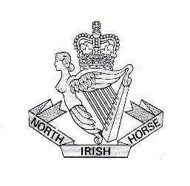
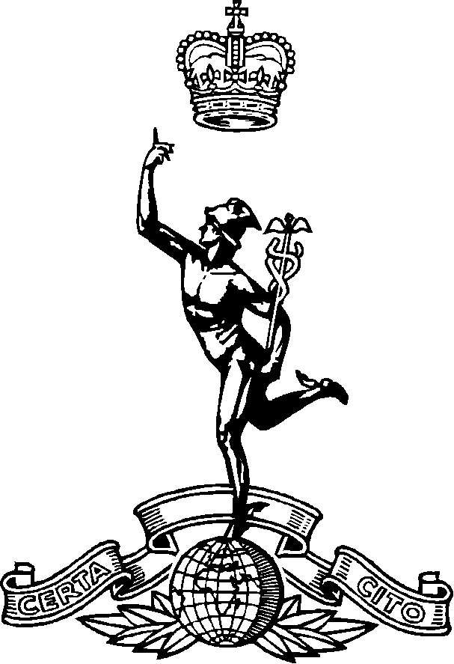
The North Irish Horse Association
Londonderry
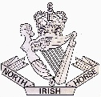
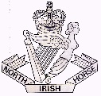

All Members & Guests 7th May 2022

NIH “HITLER LINE” Annual Dinner 18th June 2022

The annual “Hitler Line” dinner takes place on Saturday evening 18th June 2022 at the “Royal British Legion” Londonderry and we do hope you will all be able to participate in this event. This year we celebrate the 78th Anniversary of the Battle of the “Hitler Line”, which took place in Italy on 23rd May 1944.

The event taking place:-

Saturday 18th June 2022 – NIH Annual “Hitler Line” dinner at the “Royal British Legion” Iona Terrace, Londonderry – 7.00pm for 7.30pm.

To assist the committees who are organising this events, may I request, that you fill in your returns as soon as possible, or by the latest date requested on the attached return and forward to me, with your remittance to the address below. The Royal British Legion management need to know up front the numbers attending.

We look forward to seeing you at this event.

Raymond

SR Atkinson
Secretary
NIH Londonderry

The North Irish Horse
(Londonderry)
To: APPENDIX “D”

Mr SR Atkinson,
Address Below:
From: ……………………………………

Date: …………………………………….

North Irish Horse Annual “HITLER LINE” Dinner 2022

- *I will/*will not be attending the Annual dinner at:
The “Royal British Legion” Iona Terrace, Londonderry on Saturday 18th June 2022.

Dress: Gentlemen: Suits & Regimental Ties.
Ladies: Suitable equivalent. Serving & Former Members - NIH Rosettes.

7.00 pm for 7.30 pm

I will be accompanied by:-……………………………………………………
……………………………………………………
……………………………………………………
……………………………………………………
Please choose your choice of meal below:
Name | Soup & Roll | Roast Beef  or  Turkey & Ham.  Selection of Vegetables.  (Vegetarian on request). | Apple Tart & Custard,  Chocolate Fudge Cake,  Strawberry Cheesecake. | Tea/Coffee

**THE COST OF THE DINNER WILL BE £15.00 PER HEAD

Signed: …………………………………….Dated: …………………………………
- Returns are requested and to be with me by:
Monday 13th June 2022 along with payment please!!
**Cheques to be payable to: NIH Association Londonderry

